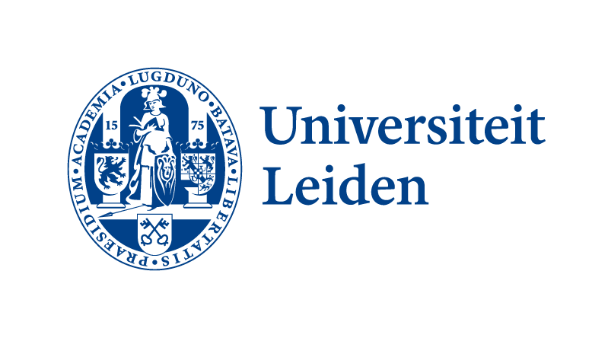
Application form Kiem grant 2026
By submitting an application, you agree to the condition of working with "open proposals". This means that the title, abstract and participants of eligible proposals will be made public regardless of whether they were awarded in the lottery. See here for the overview of 2024 and 2025. Before completing this application form, we recommend you first consult the eligibility conditions, the FAQs, and recommendations from previous applicants.
Resubmission?
When resubmitting a Kiem application that was previously not granted, please do copy the prior application into this new form and update where relevant.

Title of application*
Dutch title, maximal 20 words.
English title, maximal 20 words.

Brief summary*
Maximal 250 words.

Main contact Kiem grant*
Name | Faculty/Unit | University email adress

Participating colleagues*
Name | Faculty/Unit | University email adress

Intended duration of project*
Start date (not before 1 August 2026 and not after 31 December 2026) | End date (max. 12 months after start)

Description project objective
Provide an explanation (maximum 2 A4) of the project. Make clear which interdisciplinary goal is being pursued in the field of education, research and/or organisation. Explain concretely how the initiative promotes the development of new interfaculty collaborations and/or encounters, and how, for example, the composition of the team, the set-up and/or the method of the initiative contribute to this. Also indicate to what extent it is a new initiative and how it relates to any previous or existing collaborations of those involved.

Description of activities and planning
Describe what will be done for the benefit of the project and within what time frame (maximum 1 A4). Assume a maximum duration of 12 months (see project duration above) and consider carefully what can realistically be realized by the team within this timespan and with the resources of the grant.

Description resource deployment
Break down by activity what the Kiem funds will be used for. Specify the intended use of the grant. Assume a budget of €10,000.
Activity | Month(s) | Expenditure
 |  | Total
 |  | (Add up the amounts, maximum €10,000)

Filing this application
After fully completing this form, by 11 May 2026 17:00h we ask you to:
- save the completed application form as a Word document;
- open the Formdesk module for Kiem 2026
- in the Formdesk module, include the parts from the application form marked with a ‘*’ - i.e. the title, summary, main contact, participating colleagues and duration - in Formdesk as well;
- upload the entire application form as a Word file.
After submission, you will see a confirmation screen in Formdesk. After the closing date of the call, the received applications are checked for admissibility. You will be informed of the outcome between 27 and 29 May, possibly with a request to make a final adjustment before 2 June end of day. The admissible proposals will participate in the draw on 11 June from 16.00-18.00h at The Field, Leiden.
From the working method with ‘open proposals’, the title, abstract and participants of admissible applications will be made public regardless of the award in the draw. The other parts of the application, i.e. the description of the project's objective, the activities and planning, and the deployment of resources, are not made public. See the ‘open proposals’ overview of Kiem 2024 and overview of Kiem 2025.

