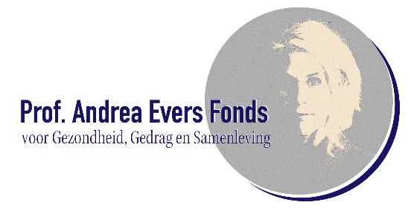
APPLICATION FORM
Prof. Andrea Evers Fund for Health, Behaviour and Society
Deadline 23-3-2026

Project title
Title of your project

- Administrative information
  - Contact details main applicant
Institution (WO): | Leiden University, Faculty of Social and Behavioural Sciences
Department:
Name applicant:
Position:
Title and gender:
Phonenr:
Email:
Mailing address:

  - Contact details collaboration partner
Institute/organisation:
Contact person:
Title:
Phonenr:
Email:
Mailing address :

1.3 If applicable: other project members
- Project summary

Duration (max 12 months):
Total requested budget (€):

Provide a brief description of the project, including the main research question, approach, expected impact and involved (scientific and/or societal) partner(s) (max 250 words).

- Criteria (max. 4 pages)
  - Scientific quality and innovation
Describe:
- The originality of the research and how it differs from existing projects/studies.
- The scientific basis and methodological soundness of the approach.
- The potential contribution to the behavioral and health sciences.
  - Relevance for health, well-being and resilience
Describe:
- How the project contributes to promoting or understanding health, well-being, and/or resilience.
- At what level (individual, community, policy) the impact is expected.
- The societal relevance and potential application of the results.
  - Collaboration and interdisciplinarity
Describe:
- The strength and complementarity of the partnership (academic and societal).
- The method of inter/transdisciplinary collaboration within the project.
- Demonstrable or intended co-creation with societal partners.
- How knowledge exchange and sustainable collaboration are promoted.
  - Feasibility and practicality
Describe:
- The project objectives and milestones.
- The work plan (methods and deliverables).
- Expected output and impact.

- Appendices
  - CVs of main and co-applicants (max. 2 pages per person)
Include your name, current position, organization, and contact information, followed by your education and academic background. Then briefly describe your current work and previous work experience that are relevant to the project. Mention some key publications, projects, skills, or collaborations that illustrate your expertise, and add any awards, prizes, or relevant memberships.
  - Overview of relevant previous collaboration or co-creation initiatives
Briefly describe the partners you have worked with, what the purpose of this collaboration was, and what results or experiences emerged from it.
  - Detailed budget
€25,000–€40,000 (seed funding) can be requested per project. Provide a clear overview of all costs required to carry out the project. Distinguish between personnel costs (such as salaries, hours worked or FTEs for researchers, project leaders, and support staff) and material costs (such as equipment, materials, travel, and other project-related expenses) and explain why these are necessary for project implementation. Additionally, where relevant, include costs for knowledge exchange, communication, and valorization, as well as any project management and coordination costs.

- Declaration main applicant
The undersigned declares that all documents required for the application are enclosed and that he/she is familiar with the requirements and procedures for this call.

Truthfully completed:

Name:

Place:

Date:

Please send the enclosed form and appendices to info_aevers@fsw.leidenuniv.nl by March 23, 2026.

