Portfolio
Senior Teaching Qualification (SKO)


Name :
Position :
Faculty :
Institute :
E-mail :
Telephone :
Date :

Content

Teaching CV 3
1 Vision on teaching and learning 7
2 Creating and developing a didactic design 9
3 Preparation and implementation of teaching 10
4. Coordinating and assuring the quality of the teaching provided and impact 11
Closing remarks…………………………………………………………………………………………...12 Appendices: 12

Introductory statement

An SKO lecturer serves as a role model in academic teaching and education for colleagues within and outside their own field of expertise. They are prepared to provide advice and inspiration on a didactic approach to designing and implementing teaching that contributes to students’ knowledge and skills.

Teaching CV

Your Teaching CV shows the study programmes you have followed, the positions you have held, and your teaching experience in (higher) education.

- General
Last name
First names (in full)
Date of birth
Place of birth
Current position
FTE of appointment

- Education (after secondary education)
Date (from/to) | Study programme | Institution
- present
-
-
-
-
-
-
-

- Positions held
Date (from/to) | Position | Institution
- present
-
-
-
-
-
-
-

Total number of years of teaching experience after PhD
Or: (clinical) qualification and years of experience. And amount of years of teaching experience after obtaining this qualification.

- Teaching experience
Display and describe your teaching experience in academic education. Base this on your work over the past five years and illustrate the breadth and variation of your teaching experience.

Teaching experience
Course, topic, theme | Curriculum component and when delivered | Level/target group (BA, MA, postgraduate programme, other…) | Activity (designing, developing, implementing, supervising, coordinating etc.) | Amount of students

- Education-related committees and boards/administrative role
Have you participated during the past 10 years, or do you currently participate in an Education Committee, Programme Committee or Board of Examiners, or do you fulfil (or have you fulfilled) an administrative role in the teaching and/or the study programme?

Committee/board/administrative role | When (from/to)
 | -
 | -
 | -

- Educational/didactic courses, training programmes and education conferences
What training have you followed in the area of teaching? Examples here could include courses, training programmes, workshops, study programmes, conferences, University Teaching Qualification (BKO) modules, etc.

In possession of UTQ since

Training (followed) | Duration of course  (in days) | Year

- Contribution to educational/didactic courses, training programmes and education conferences
What contribution have you made to educational / didactic courses, training programmes or education conferences?

Contribution to courses, training programmes or conferences | Year

- Teaching prizes and nominations
Have you ever received an education prize for your teaching or for your block? Or have you been nominated for one?

Prizes / nominations | Year

- Grants
Have you ever applied for or received a grant for a project for educational improvement / renewal?

Grant | Year

- Activities in the area of teaching/educational innovation outside Leiden University
Do you participate in a national consultative committee or are you a member of a board in the area of teaching and education? Are you a member of an association for education? Are you on the editorial board of a journal in the area of education?

National activities in the area of education | When (from/to)
 | -
 | -
 | -

- Publications
Have you published about research on education in your discipline or about education in general? Have any news reports been published about your teaching / educational innovation?

Publications / presentations on education | Year

Vision on teaching and learning

Criterion 1 | Acting from within the academic learning environment
Operationalisation | The candidate is demonstrably able to:  1. clearly define their own vision on teaching and learning.  2. describe which ways of thinking and working within their field of expertise form the basis of their own vision on teaching and learning.  3. relate their own vision to Leiden University’s vision on teaching and learning, including the ambition of ‘integration of research and teaching’.  4. reflect on the implementation of their own vision on teaching and learning in practice and to show how these practical experiences have, in turn, contributed to developing their own vision.

In a maximum of 1000 words, give an explanation of your vision on teaching and learning, as set out in Criterion 1 of the Senior Teaching Qualification (SKO):
You teach in a specific discipline, such as archaeology, theoretical physics or law. After students have received this education, you expect them to have acquired specific ways of thinking and acting and specific attitudes; for instance, that they are able and inclined to ask specific types of questions and to take a specific approach to answering these questions and to critically testing those answers. The precise form this takes will be different for every discipline: an archaeology student will be expected to display different ways of thinking and acting and different attitudes than a student of theoretical physics or law. Students will ask other questions, learn other research methodologies and require other skills. In practice, this will vary for every field.

In your vision on teaching and learning, you should describe and justify your vision in as concrete terms as possible. You could think about what you want to achieve with your students and why, and which ways of thinking and working and attitudes you feel need to be instilled in students. You should specify which educational principles are important to you in implementing your vision on teaching and learning. How do you view learning? What does integrating teaching and research mean for your teaching? Next, you should explain how you feel assessment forms part of the learning process – both summative and formative – and which assessment methods align with the ways of thinking and working and attitudes that you consider important. How do you view the latest relevant developments affecting education and to what extent does this play a role within your own vision on teaching and learning?

In this section, pay attention to how you connect teaching and research. There is no one best way to do this. There is a wide variety of ways in which research and teaching can be linked: teaching about research findings, discussing the design and results of research, showing what it means to be a scientific professional, offering help in conducting research, or discussing research experiences. One option is to use Healey's model (see Figure I).

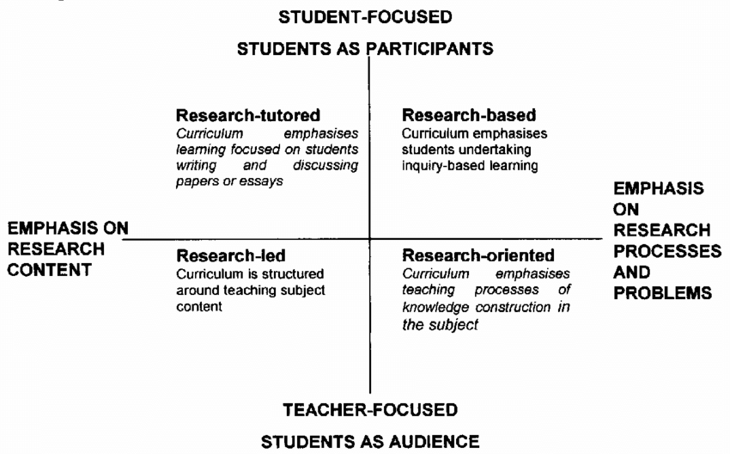

You should then substantiate your vision based on the nature of your fields of expertise and didactic or educational research. Also explain how your teaching experiences have contributed to the development of this vision. Lastly, show how your vision on teaching and learning is positioned in relation to your own fields of expertise and Leiden University’s vision on teaching and learning.

Creating and developing a didactic design

Criterion 2 | Creating and developing a didactic design, taking account of the context of a curriculum
Operationalisation | The candidate is able to:  1. explain how constructive alignment¹ is implemented in their own teaching, within their own course, within learning pathways and within the entire curriculum of which their own course is a part.  2. develop coherent teaching and education comprising multiple study components, describe their own role therein and reflect on this.  3. substantiate how the teaching and education they provide meaningfully relates to the broader curriculum of the study programme (e.g. learning pathways, multi-year tracks).  4. develop appropriate tests that support the student’s learning process (formative), assess learning performance (summative) and substantiate how the assessment design aligns with their personal vision.

In a maximum of 1000 words, describe a didactic design in which you have been involved (in both the design and the implementation), corresponding to your vision.

You should formulate the context of the relevant learning pathway and justify the decisions made based on your vision on teaching and learning. Describe how constructive alignment is implemented in your own course, in the learning pathway and in relation to the curriculum.

What should a student know and be able to do by the end of the course or learning pathway, and how do these skills and knowledge contribute to the objectives of the entire curriculum?

Which learning principles is your course or the learning pathway structured on and why was this structure selected? How do the various study components contribute to this?

Based on your professional vision on testing and assessment, reflect on how you assess students' learning progress and learning outcomes in a way that aligns with the learning objectives.

Preparation and implementation of teaching

Criterion 3 | Preparation and implementation of teaching
Operationalisation | The candidate is able to:  1. describe their broad repertoire of didactic approaches that they apply when providing teaching and education that:  1. enables students to acquire the desired ways of thinking and working;  2. factors in differences between students;  3. encourages students to take responsibility for their own learning process.  2. reflect on their own teaching and course-specific behaviour based on systematically collected data and use this information to improve their teaching.

In a maximum of 1000 words, indicate how you ensure in your teaching that students actually acquire the desired ways of thinking, attitudes and acting that you described in your vision and design.
Describe and justify the didactic strategies you use for this process and how you implement them in the teaching and education you provide.
Describe how you take account of differences between students in this teaching and how you encourage them to steer and monitor their own learning process. On the basis of what insights and data do your improve your teaching? Illustrate this with a few concrete improvements you have made in the last two years. Finally, also reflect on the results of the teaching evaluations you have attached to this portfolio. Also indicate how you use the results of tests to evaluate the effect of the education offered and adjust the education where necessary.

4 Coordinating and assuring the quality of the teaching provided and impact

Criterion 4 | Impact on vision on teaching and learning, design and implementation within one or more study programmes that extends beyond the candidate’s own teaching practices.
Operationalisation | The candidate is able to:  1. demonstrate their specific role or contribution in the development of the vision on teaching and learning and didactic design within one or more study programmes and show how this is implemented within the various study components.  2. describe their own leadership style – formal or informal – in promoting their own vision on teaching and learning and explain what effective communication with colleagues on didactic design looks like (within and potentially outside the university).  3. reflect on their own didactic design and performance using feedback that they have proactively requested and obtained, demonstrating personal leadership by systematically interpreting and reflecting on the feedback and managing the implementation of the resulting adjustments within the various study components.  4. demonstrate how they make a contribution as a ‘mentor’ to the development of colleagues and professional peers in their role as members of teaching staff.

In a maximum of 1000 words, indicate what contribution you have made to the development of a vision on education within one or more study programmes. How have you ensured discussion and communication with and between teaching staff, and to what extent has this contributed to team development and effective implementation of the vision? How have you made a contribution as a mentor to the (professional) development of your colleagues and/or specialists in your field in their role as a member of teaching staff? Do you have, or have you had, an impact in any other way(s) on the teaching that extends beyond your own study components within or outside Leiden University? How do you deal with feedback? Are you proactive in asking for it? How do you reflect on feedback you have received and implement the resulting adjustments? How is data from the quality assurance system used?² As a mentor, how have you contributed to the development of colleagues and professional peers in their role as members of teaching staff?

Closing remarks:
To conclude, the committee is interested in finding out what you have gained from this SKO process. What have you learned? What are your takeaways from this process? What are your focus areas over the next five years in terms of your professional development as a lecturer, and what will be your first step?

Appendices:
- List of referees (e.g. manager, Programme Director, chair of Programme Committee, chair of Board of Examiners, student), including contact details.
- Evaluations:
- official student evaluations of three courses from the past three years;
- the candidate’s own evaluation method (students/lecturers);
- previous reflections written by the candidate for the purposes of a programme committee or supervisor.

General criterion 2: The candidate has a PhD and/or can demonstrate, by means of a (clinical) qualification and more than 4 years of experience, that she/he possesses specialist knowledge and skills from professional practice with demonstrable value for academic education. Explanation: - Qualification: every professional field does have formal qualifications. If this is not the case for your field, a statement from a few referees will suffice. In addition, you can indicate why you think you qualify for the STQ. - Years of experience are years in which you spent a substantial part of your time (think 16 hours per week) performing your professional practice.
Visser-Wijnveen, Gerda J. , Van Driel, Jan H. , Van der Rijst, Roeland M. , Verloop, Nico and Visser, Anthonya(2010) 'The ideal research-teaching nexus in the eyes of academics: building profiles', Higher Education Research & Development, 29: 2, 195 — 210, DOI: 10.1080/07294360903532016
Healy 2005

